|  |  |  |
| --- | --- | --- |
|  |  | Impact of Opioid Control Policies |

November 28, 2023

Effect of opioid drug prescription regulations on the volume of opioids prescribed and drug overdose deaths.



*Faraz Jawed*

*Tina Yi*

*Keon Nartey*

*Shaila Güereca*

**Table of Contents**

Executive Summary 3

Analysis 3

Motivation of the project 3

Florida 4

Texas 4

Washington 4

Research Method 4

Overview of the Data 5

Data Integration and Normalization 5

Data Cleaning and Imputation 5

Mortality 5

Population 6

County names cleaning 6

Methodology 6

Pre-Post Analysis 8

Florida 8

Washington 9

Texas 9

Overall Comments on Pre-Post Analysis 10

Difference in Difference (DiD) Analysis 11

Florida 11

Washington 12

Texas 13

Overall Comments on Diff-in-Diff Analysis 14

Strengths and Limitations 14

Strengths: 14

Limitations: 14

Conclusion 15

Appendices 16

References 19

# Executive Summary

This analysis delves into the efficacy of opioid prescription regulations in Florida, Texas, and Washington, addressing the urgent concerns of government officials and stakeholders. To evaluate the effectiveness of the policies in each of the three states, we conduct a 1) Pre-post analysis before and after the policy, and 2) A difference-in-difference analysis to isolate the impact of the policy by attempting to select control states with a similar trend before each policy being implemented for all three states.

The two metrics we use to evaluate the policies are the **mortality rate** and incoming shipment in terms of **Morphine Milligram equivalents** (**MME per capita**). While these metrics might not fully capture the impact of these policies on opioid usage, they serve as a useful proxy for the effectiveness of the policies.

Our pre-post analysis suggested an initial success for all three policies in all three states, however after conducting a difference-in-difference analysis we concluded the policy implemented in Washington and Texas to not be entirely effective. To conclude it all, Florida’s policy seemed to have the highest impact and its comprehensive strategy, including Operation Pill Nation, emerged as notably the most effective.

# Analysis

## Motivation of the project

From 1999 to 2014, over 165,000 lost their lives due to overdose related prescription to opioids in the United States, with an estimated 17,087 prescription opioid overdose deaths in 2016. This increase was accompanied by marked increases in rates of opioid use disorder and drug overdose mortality involving prescription opioids for chronic pain. Opioids were involved in 33,091 deaths in 2015, according to the Centers for Disease Control and Prevention (CDC), and opioid overdoses have quadrupled since 1999. In October 2017, the U.S. Department of Health and Human Services declared a nationwide public health emergency regarding the opioid crisis.

Chronic pain is defined as pain lasting longer than 3 to 6 months, or past the time of normal tissue healing. The Centers for Disease Control and Prevention (CDC) estimates that 20.4 percent of U.S. adults in 2016 had chronic pain and 8.0 percent had high impact chronic pain. Chronic pain is associated with a variety of conditions and influenced by multiple biological, psychological, and social factors. Effective management requires a holistic approach considering these aspects. While long-term opioid use can provide relief, it poses a risk of addiction, underscoring the importance of strict medical supervision when prescribing opioids for prolonged periods.

In the United States, prescription of opioid medications for chronic pain more than tripled from 1999 to 2015. Nationally, opioid prescribing trends began to plateau in 2010, likely due to implementation of opioid-related practice guidelines and other state-based initiatives. However, overdoses involving heroin, and more recently illicitly manufactured fentanyl, markedly increased since 2010. Most heroin users report their first opioid of abuse was a prescribed opioid, and concerns have been raised that efforts to reduce prescribing may result in unintended consequence of increased illicit opioid use.

The policy changes in these states were as follows:

### Florida

By 2010, the state hosted a majority of U.S. physicians with the highest direct oxycodone dispensing rates. In response, Florida implemented measures, including mandatory registration for pain clinics, initiating Operation Pill Nation in 2010, and expanding regulations. Statewide raids in February 2011 led to arrests, asset seizures, and clinic closures. A public health emergency declaration in July 2011 prompted legislative action, prohibiting physicians from dispensing schedule II or III drugs and activating regional strike forces. Mandatory reporting to the prescription drug monitoring program began in subsequent years.

### Texas

In 2007, the Texas Medical Board implemented regulations for the treatment of pain with controlled substances. These guidelines entail conducting a thorough patient evaluation, including a review of the patient's prescription history in the state's prescription drug monitoring program (PDMP). Additionally, healthcare providers are required to obtain informed consent from the patient before initiating opioid treatment, conduct periodic reviews of the opioid treatment, and maintain comprehensive medical records documenting the patient's treatment history.

### Washington

In 2012, Washington included the addition of specialized consultations for patients who needed doses of opioids greater than 120/mg/day and a greater emphasis on recording these special consultations and for patients who were stable 40 mg/day or less.

For the effectiveness of the comparison analysis of these states, we compared the data to a group of states where fewer restrictions were enacted. This enables us to compare the number of opioid prescriptions and overdose deaths in our base states, where there was a policy change and one without.

## Research Method

The primary objective of this project is to examine the interventions in 3 states’ opioid policies in lowering the volume of opioid prescriptions and the rate of drug overdose mortality to answer these questions.

* What is the impact of opioid drug prescription regulations on the volume of opioids prescribed in Florida and Washington?
* What is the impact of opioid drug prescription regulations on drug overdose deaths in Florida, Washington, and Texas?

Our analysis is grounded on causal inference and will primarily employ two approaches.

* Pre and Post Analysis - A pre-post analysis involves examining changes in a variable or outcome before and after the implementation of a particular intervention, policy, or event. It allows for the identification of potential cause-and-effect relationships and is particularly valuable in understanding the effectiveness of interventions and policy changes. In our case, we are doing a pre-post analysis for the three states above where the government implemented a policy to control drug usage.
* Difference-In-Difference Analysis - Difference-in-difference (DiD) analysis estimates the causal effect of a specific treatment by comparing the changes in outcomes over time between a treatment group and a control group. In our case, the treatment is the policy that the government implemented to control drug usage in each of the three states. These three policy-change states are our treatment groups. We selected three control states that did not undergo policy change for each of the three treatment states based on similar socioeconomic characteristics and similar trends they exhibited with the treatment states before the policy change was studied.

## Overview of the Data

The analysis is focused on examining the effect of Opioid policies in Texas, Florida and Washington and is grounded within three primary datasets:

1. [Vital Statistics Mortality dataset](https://www.dropbox.com/s/kad4dwebr88l3ud/US_VitalStatistics.zip?dl=0): This contains the cause of death for each death in the US, but for our analysis the deaths related to **drug usage** were extracted.
2. [The Washington Post’s DEA pills dataset](https://www.washingtonpost.com/national/2019/07/18/how-download-use-dea-pain-pills-database/?arc404=true): This dataset provides county level information on the flow of drug shipment in the US between 2006 and 2015. This is useful to understand the quantity of pain pills being transacted from manufacturers to pharmacies.
3. [NHGIS’s data on population (county level)](https://www.nhgis.org/): This National Historical GIS database has information on various metrics and we extracted county level estimated population data for the years required.

## Data Integration and Normalization

All three datasets were merged and cleaned based on a **county-state-year** common denomination to normalize the data on population and arrive at our two main comparison metrics namely “MME rate” and “Death rate” for each county in a particular year, which are basically the **Morphine Milligram Equivalent per population** and **drugs related deaths per population** for each county in the US. These metrics help us analyze if the policies were helpful in reducing the shipments in our treatment states.

## Data Cleaning and Imputation

### Mortality

The Vital statistics dataset for mortality excludes the number of deaths if they were less than 10 for a category for a particular county (to maintain anonymity). Because of this, we had to impute the data for Death rate in the counties which had missing data for deaths. The reason why Death rate was used instead of the absolute deaths is because we can’t just average out absolute numbers and replace those since the reason for the missing data is because it’s less than 10. When you average out the rates, the data is normalized according to population and you just impute the rate itself, which is more realistic.

### Population

The NHGIS website didn’t have complete data for some years (particularly which were not census years). Linear extrapolation and moving averages were taken to fill in the missing data, hence the populations are estimates.

### County names cleaning

County names are written differently by different sources, which caused a few troubles when merging datasets and arriving at a final dataset to perform our analysis. Some counties have the word ‘parish’ after the county names (particularly for Louisiana). Some counties write DePaul and De Paul or similar states differently). After much trial and error we were able to consolidate most of these county mismatches and then we merged the datasets.

# Methodology

Evaluating the impact of opioid drug prescription regulations on prescription volume and overdose deaths requires careful consideration of various social and economic factors that can influence these outcomes. Selecting control states with similar socioeconomic characteristics to the state being studied is crucial when analyzing factors that contribute to opioid prescribing and overdose deaths. This ensures that any observed differences in opioid-related outcomes are not solely attributable to underlying socioeconomic disparities. By selecting control states with comparable levels of poverty, unemployment, healthcare spending, and median income, we can better isolate the effects of policy changes:

**1. Poverty Rate:** Individuals living in poverty are more likely to experience chronic pain, which can increase the likelihood of being prescribed opioids. They may also face barriers to accessing treatment for opioid addiction due to financial constraints. Therefore, selecting control states with similar poverty rates allows us to control for this potential confounding factor.

**2. Unemployment Rate**: Unemployment can lead to stress, anxiety, and social isolation, which are all risk factors for substance abuse, including opioid misuse. Additionally, unemployed individuals may have less access to healthcare services, including addiction treatment. By choosing control states with similar unemployment rates, we can minimize the influence of this factor on our analysis.

**3. Healthcare Spending per Capita:** Healthcare spending per capita reflects the overall level of resources available for healthcare in a state. Variations in healthcare spending could influence access to treatment for opioid addiction, potentially affecting overdose rates. Selecting control states with comparable healthcare spending per capita helps to control for this potential bias.

**4. Median Household Income:** Median household income is a broad indicator of a state's overall economic well-being. Higher income levels may be associated with better access to healthcare services, including addiction treatment. Conversely, lower income levels may increase the risk of opioid misuse due to factors such as stress and social isolation. By selecting control states with similar median household incomes, we can control for the potential impact of economic disparities on opioid-related outcomes.

These are the indicators for the state of Florida and selected control states:

|  |  |  |  |  |
| --- | --- | --- | --- | --- |
| State | Poverty Rate 2009 | Unemployment Rate 2009 | Healthcare Spending per Capita USD 2009 | Median Household Income USD 2009 |
| Florida | 14.9% | 10.5% | $7,118 | $45,577 |
| Ohio | 15.2% | 10.2% | $7,242 | $46,241 |
| Oklahoma | 16.2% | 6.4% | $6,514 | $42,515 |
| Arkansas | 18.8% | 7.3% | $6,223 | $38,441 |

These are the indicators for the state of Washington and selected control states:

|  |  |  |  |  |
| --- | --- | --- | --- | --- |
| State | Poverty Rate 2011 | Unemployment Rate 2011 | Healthcare Spending per Capita USD 2011 | Median Household Income USD 2011 |
| Washington | 13.9% | 9.2% | $7,022 | $57,201 |
| Oregon | 17.5% | 9.5% | $6,987 | $47,989 |
| Massachusetts | 11.6% | 7.4% | $9,720 | $63,967 |
| Maryland | 10.1% | 7.0% | $7,928 | $70,976 |

These are the indicators for the state of Texas and selected control states:

|  |  |  |  |  |
| --- | --- | --- | --- | --- |
| State | Poverty Rate 2006 | Unemployment Rate 2006 | Healthcare Spending per Capita USD 2006 | Median Household Income USD 2006 |
| Texas | 13.3% | 4.9% | $5,275 | $44,922 |
| Alabama | 12.6% | 3.6% | $5,768 | $38,783 |
| South Carolina | 11.9% | 6.5% | $5,675 | $41,100 |
| Tennessee | 12.4% | 5.2% | $5,958 | $40,215 |

After having selected the control states most similar in these 4 factors to our states under analysis, a verification was carried out to confirm that, during the period prior to the establishment of the policies, we could observe parallel trends among the states and each control state that would allow us to consider each control state as a valid point of comparison to analyze the policies.

Considering the similarities of these factors with our target states as well as the similar trends in Mortality rate and Opioid shipment rate denoted by similar gradients (close to parallel lines), we have selected the following control states for our analysis:

|  |  |
| --- | --- |
| **States to be analyzed with policy changes:** | **Control States** |
| Florida | Ohio, Oklahoma, Arkansas |
| Washington | Oregon, Massachusetts, Maryland |
| Texas | Alabama, South Carolina, Tennessee |

# Pre-Post Analysis

A pre-post analysis involves examining changes in a variable or outcome before and after the implementation of a particular intervention, policy, or event. It allows for the identification of potential cause-and-effect relationships and is particularly valuable in understanding the effectiveness of interventions and policy changes. In our case, we are doing a pre-post analysis for the three states below where the government implemented a policy to control drug usage.

### Florida

In February 2010, Florida began implementing an Operation Pill Nation, which started a series of events and policies designed to curb the usage of opioids in the state. Although these were a series of events until 2012, we assume that 2010 was when this started, hence our reference for the pre-post analysis for Florida’s drug usage is 2010. Below are two plots for Florida with reference to death rate and opioid shipments per capita before and after 2010:

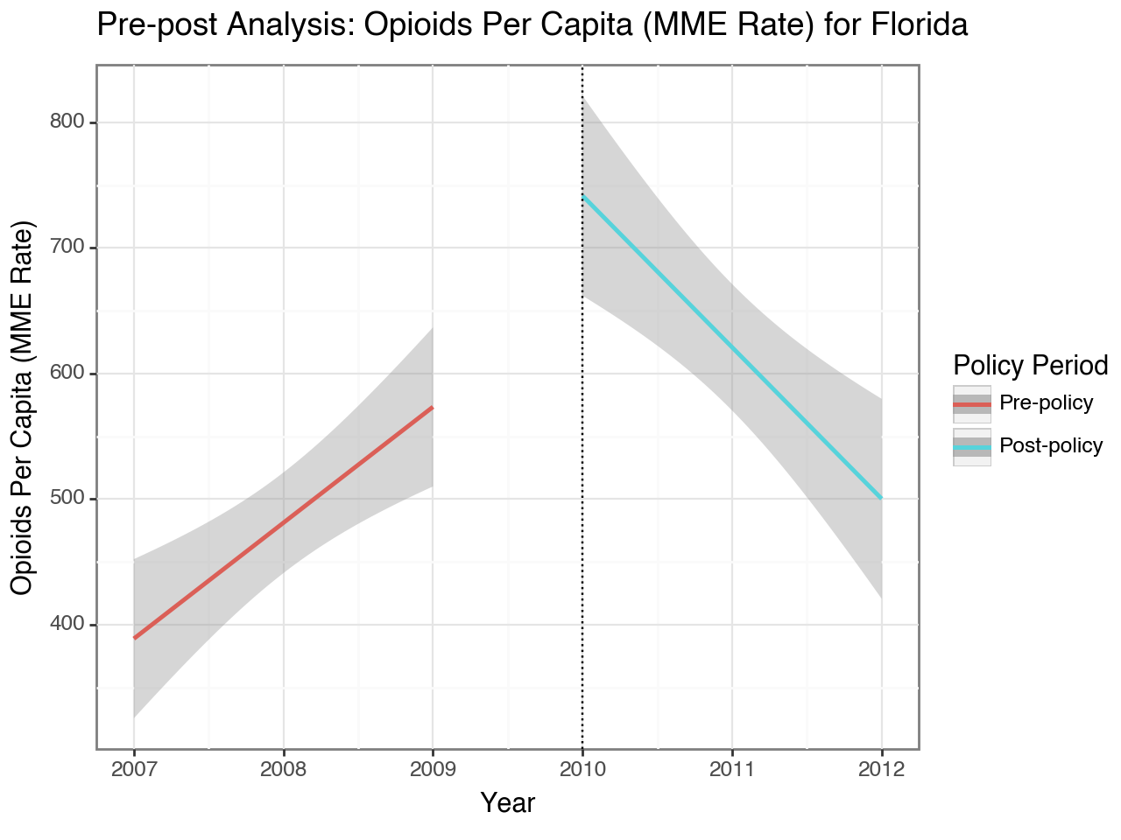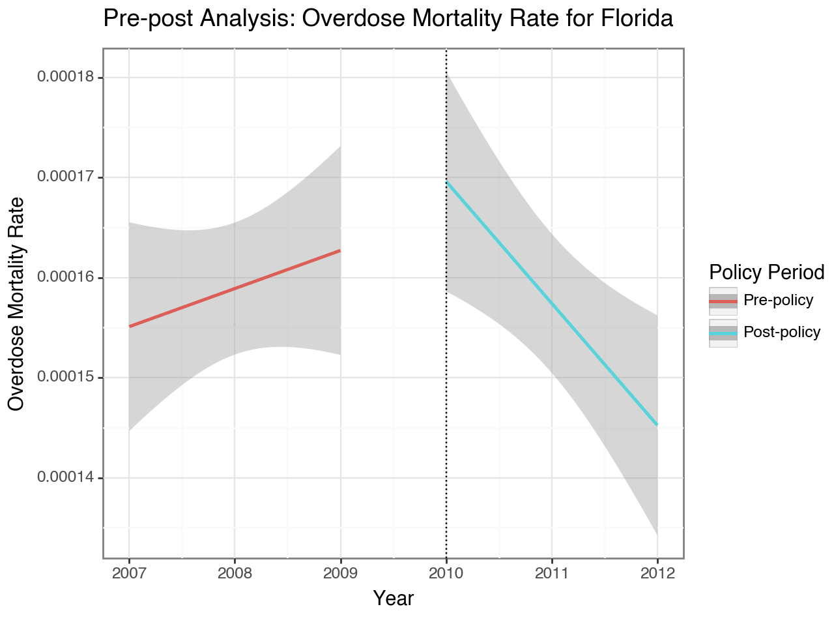

***Fig 1 and 2: The Pre-post analysis for Florida for Opioids per capita (Fig 1: Left) and Mortality Rate (Fig 2: Right)***

According to the plots above, there can be seen a decreasing trend in Opioids per capita and Mortality rate after 2010. This confirms that according to a simple pre-post analysis, the series of events to control the opioids usage in Florida was indeed a successful one. The line plots for both the graphs show a regressed line showing the overall trend for the state, obtained from the data from individual counties in Florida (shown as the gray standard error bands). For the MME rate, we can see that it increased from about 400 MME per capita in 2007 to almost 600 in 2009, but after the government’s efforts, it decreased to roughly 500 in 2012 (from almost 750 in 2010), a decrease of about **50%** in 3 years. Similarly, the Mortality rate which had risen to about 0.00017 per person, i.e 0.17 deaths per 1000 individuals reduced to roughly 0.145 per 1000 individuals, a decrease of roughly **15%** in 3 years, which is not as dramatic as the MME rate but still impressive given that in the years prior to the policy changes there was an increasing trend.

### Washington

In 2011, the Washington Department of health began implementing a series of regulations on the prescriptions on opioids for treatments such as the mandatory documentation of each consultation by physicians and a threshold limit for prescriptions. These policies were in effect in January 2012, thereby our reference year for Washington’s pre-post analysis is **2012**. The plots below show the pre-post analysis for Washington:

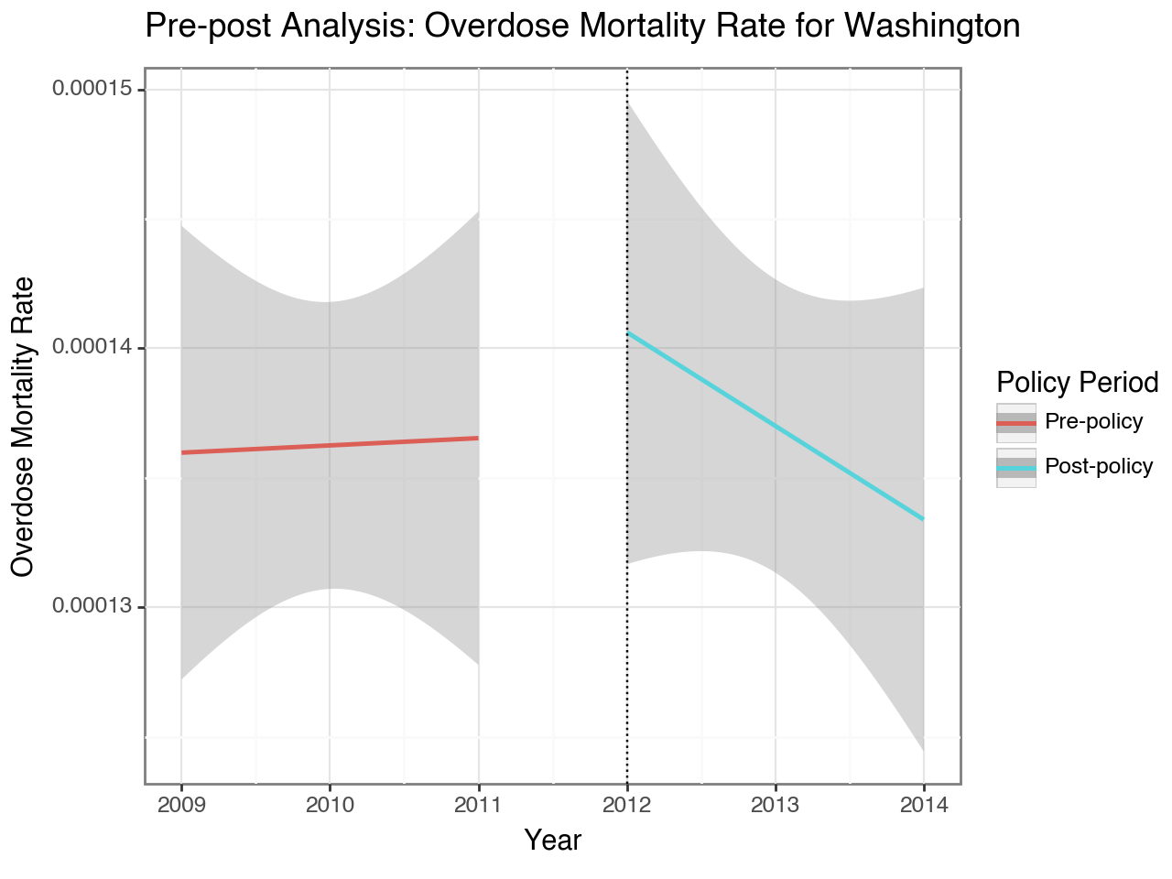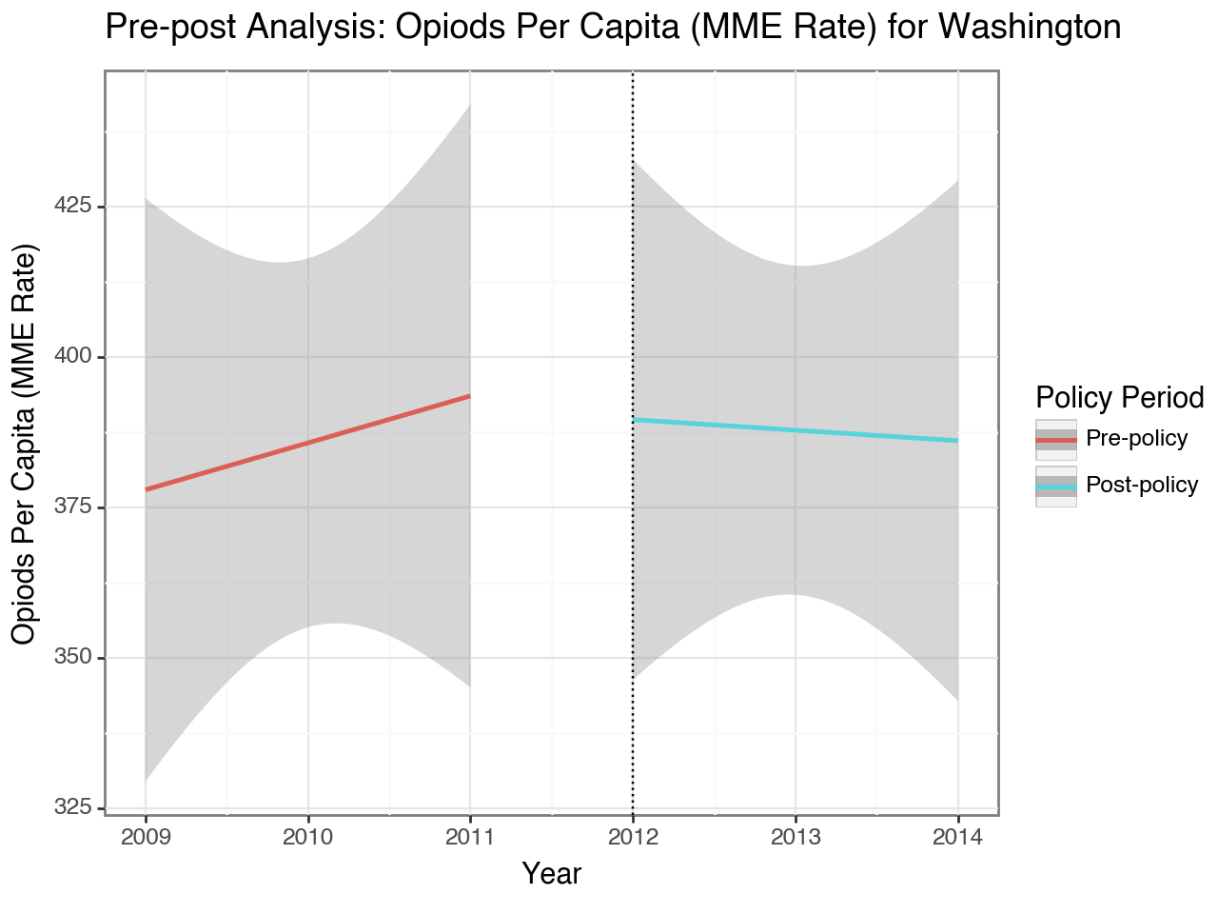

***Fig 3 and 4: The Pre-post analysis for Washington for Opioids per capita (Fig 3: Left) and Mortality Rate (Fig 4: Right)***

Similar to Florida, according to this basic pre-post analysis, there seems to be a decrease in both our metrics after the policy intervention by the Washington department of health. For Opioids per Capita, which was on an increasing trend (from ~380 to 395), the department’s efforts led to a slight decreasing trend in the years post the policy intervention. The mortality rate, albeit wasn’t on an overall increasing rate until 2011, seemed to get high between 2011 and 2012 (seemed like the department anticipated it in advance). However, we can see a sharp decline in the Mortality rate in the years after the policy change, which suggests that the policy was successful, if we consider a basic pre-post analysis.

### Texas

The Texas Medical Board, in 2007, adopted regulations towards a controlled use of substances to treat pain due to the rising trend in Opioid related problems. For the purpose of our study, we will be using **2007** as our reference year for our pre-post analysis. Since we didn’t have the *Washington Post’s Opioid data* for years before 2006, we only compare the pre and post policy analysis for Mortality rate for Texas. In the next iteration of this document, we will work on a monthly pre-post analysis for Texas based on the Opioid shipment, from 2006 onwards, to capture the monthly trend before and after policy intervention. Fig 5 below shows the plot which captures the trend for Mortality rate:

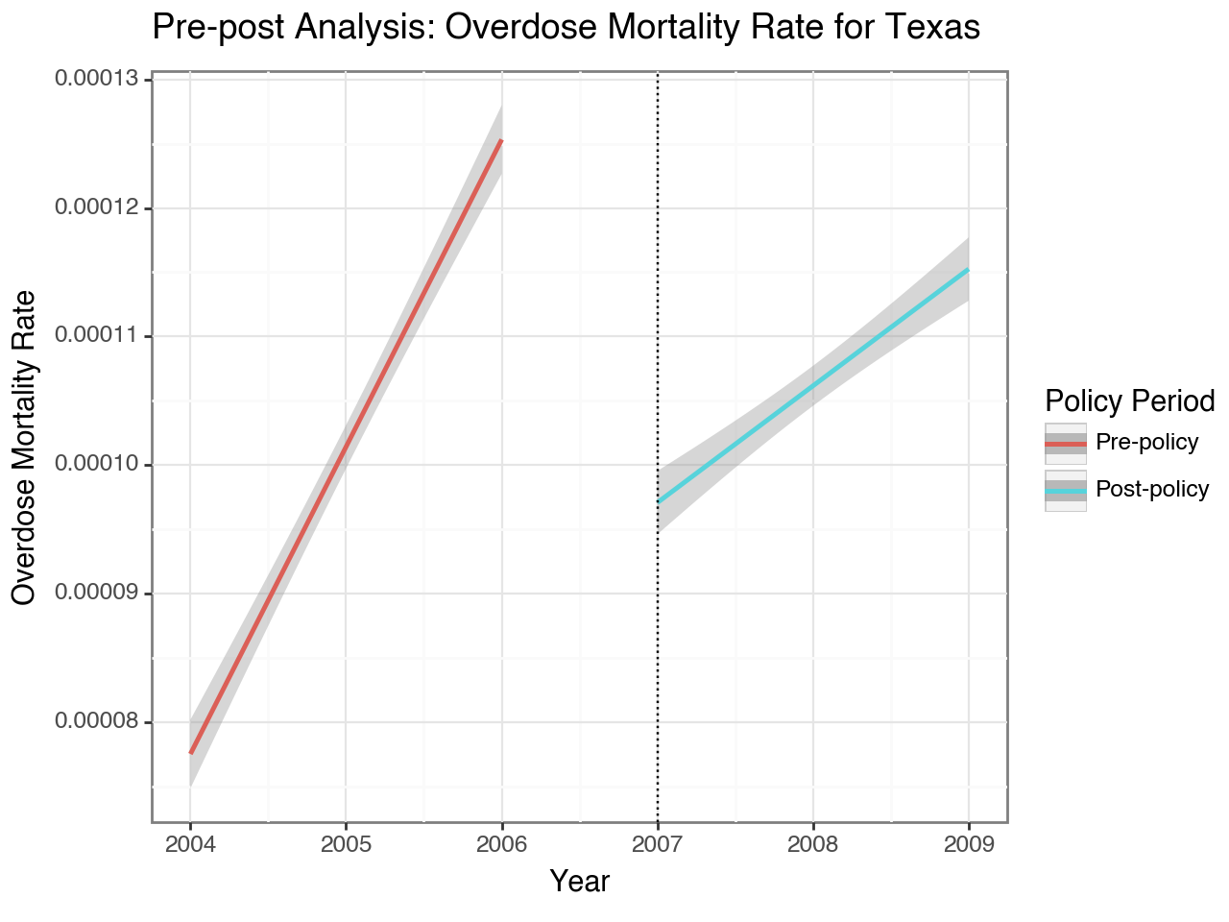

***Fig 5: Pre-post analysis based on Overdose Mortality Rate in Texas between 2004 and 2009***

An interesting finding for Texas was the narrow standard error bands when we began plotting the regressed trend for the state based on individual county data, which shows us that as compared to Florida and Washington, the Mortality rate from Opioid related causes is consistent across the state, whereas in the other two states it varied quite a lot on a county level. As far as the trend is concerned, we can see that the policy intervention, even though it couldn't reverse the trend, did lead to a *decrease in the increasing trend.* Before the policy, the Mortality rate grew from 0.08 per 1000 individuals to about 0.125 per 1000 individuals, almost a **60%** increase, whereas the increase in the rate from 2007 to 2009 was roughly **20%** thereby indicating that the policy was successful, if only a pre-post analysis was conducted, and other factors are not accounted for.

### Overall Comments on Pre-Post Analysis

According to our pre-post analysis for all 3 states, we can safely conclude that all 3 policies were indeed successful ones. However, it is integral to note that a simple pre-post analysis is not enough to gauge the *impact* of a policy because there are many other factors that come into place. This can simply just be a correlation rather than a causation. There can be other similar policies on the National scale, which led to an overall decrease in opioid usage in the US, or there can be other economic factors affecting Opioid usage. Because of the limitations of a pre-post analysis, we will now look at a difference in difference analysis, which leverages the use of a few control states, to compare the effect of a policy on the treatment state itself.

# Difference in Difference (DiD) Analysis

Difference-in-difference (DiD) analysis estimates the causal effect of a specific treatment by comparing the changes in outcomes over time between a treatment group and a control group. In our case, the treatment is the policy that the government implemented to control drug usage in each of the three states Washington, Florida, and Texas in 2012, 2010, and 2007. These three policy-change states are our treatment groups. We selected three control states that did not undergo policy change for each of the three treatment states based on similar socioeconomic characteristics and similar trends they exhibited with the treatment states before the policy change was studied.

The primary goal of our DiD analysis is to infer causal relationships and measure the effect of the drug usage control policy on each of the policy change states. Unlike simple pre-and-post analyses, DiD can control for factors that are constant over time but vary between the treatment and control groups, as well as factors that vary over time but are constant across groups. For instance, there may be US nationwide policy implementation that reduces the number of overdose deaths or opioid prescriptions throughout the US. If we simply look at pre-post analysis, we would wrongly attribute the decline in overdose deaths or opioid prescriptions to state intervention policy. By doing DiD, we can analyze if there are bigger changes in overdose deaths or opioid prescriptions in the treatment states after the opioid policy change than in other control states that didn’t undergo the opioid policy change. If the opioid policy had an effect, then we would expect opioid overdose deaths or opioid prescriptions in the treatment states to decrease differently than opioid overdose deaths and opioid prescriptions in control states without a policy change. But if the treatment states experienced a decline in overdoses because of something that happened nationally, then we’d expect to see overdoses reduce at the same rate in all states (both treatment and control).

In general, the DiD isolates the impact of the state-level control drug usage intervention policy from other factors that might influence opioid overdose deaths or opioid prescriptions, thereby providing a more accurate estimate of the intervention policy's true effect.

### Florida

Building upon the pre-post analysis, we included three control states, Ohio, Oklahoma, and Arkansas for Florida's DiD analysis. The graphs below show the overdose mortality rate and Opioids per capita in Florida versus control states (Ohio, Oklahoma, Arkansas) over the years 2007 to 2012. The opioid intervention policies in Florida were in effect in February 2010, thereby our reference year for Florida’s DiD analysis is **2010**.

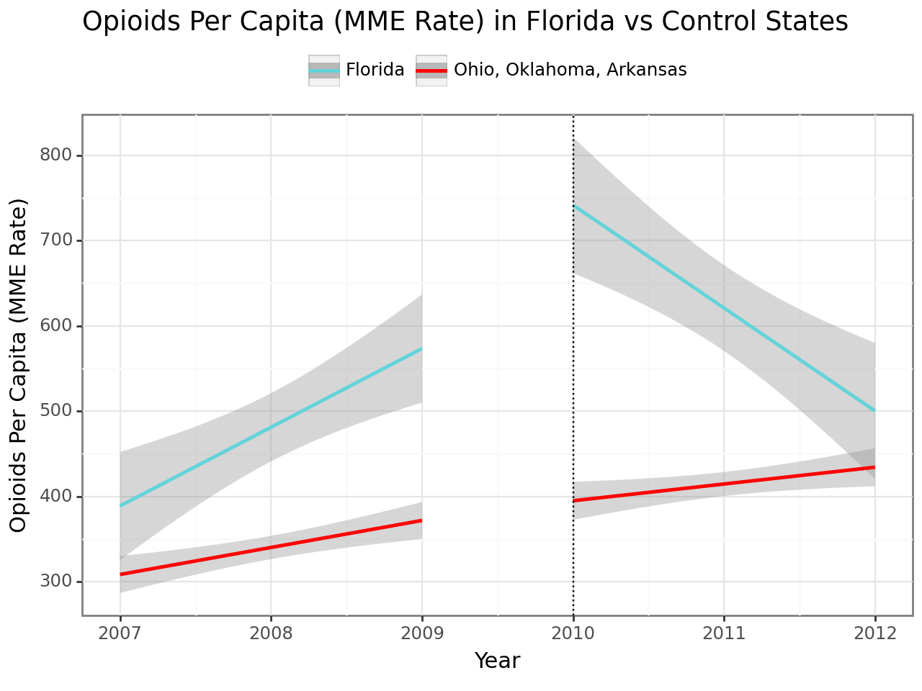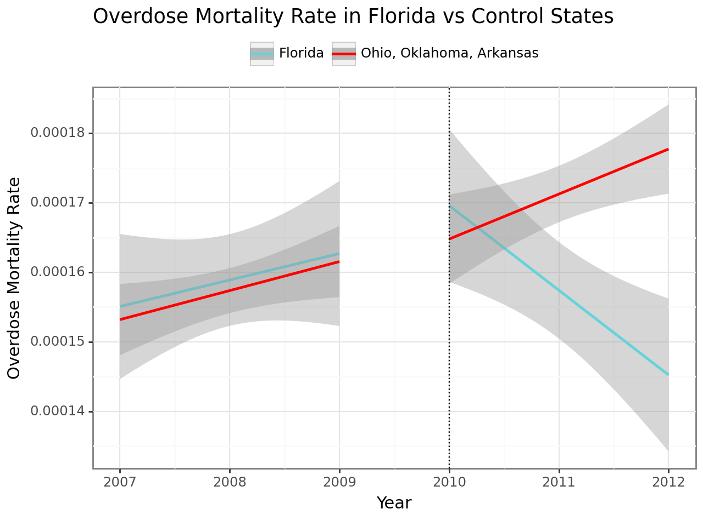

***Fig 6 and 7: The Diff-in-Diff Analysis for Florida for Opioids per capita (Fig 6: Left) and Mortality Rate (Fig 7: Right)***

Prior to the intervention policy, both Florida and the control states showed a gradual increase in overdose mortality rates. The trends in overdose mortality rates for both Florida and the control states seem to be parallel, which suggests that the two groups were comparable before the intervention. After the introduction of the policy, Florida's overdose mortality rate showed a marked decrease, whereas the control states continued on an upward trend. This divergence after the policy implementation suggests that the intervention has been effective in reducing overdose deaths in Florida. Prior to the intervention, Florida's opioids per capita rate was increasing. The control states also show an upward trend, though it appears to increase at a steeper rate compared to Florida. Although the trends for both groups were not perfectly parallel, they were sufficiently similar to facilitate comparison. After the intervention policy, Florida exhibited a significant downward trend in opioids per capita, while the control states continued to experience an increase. This suggests a strong response to the policy, indicating the intervention has been effective in reducing opioids per capita in Florida.

### Washington

Building upon the pre-post analysis, we included three control states, Oregon, Massachusetts, and Maryland for Washington's DiD analysis. The graphs below show the overdose mortality rate and Opioids per capita in Washington versus control states (Oregon, Massachusetts, Maryland) over the years 2009 to 2014. The opioid intervention policies in Washington were in effect in January 2012, thereby our reference year for Washington’s DiD analysis is **2012**.

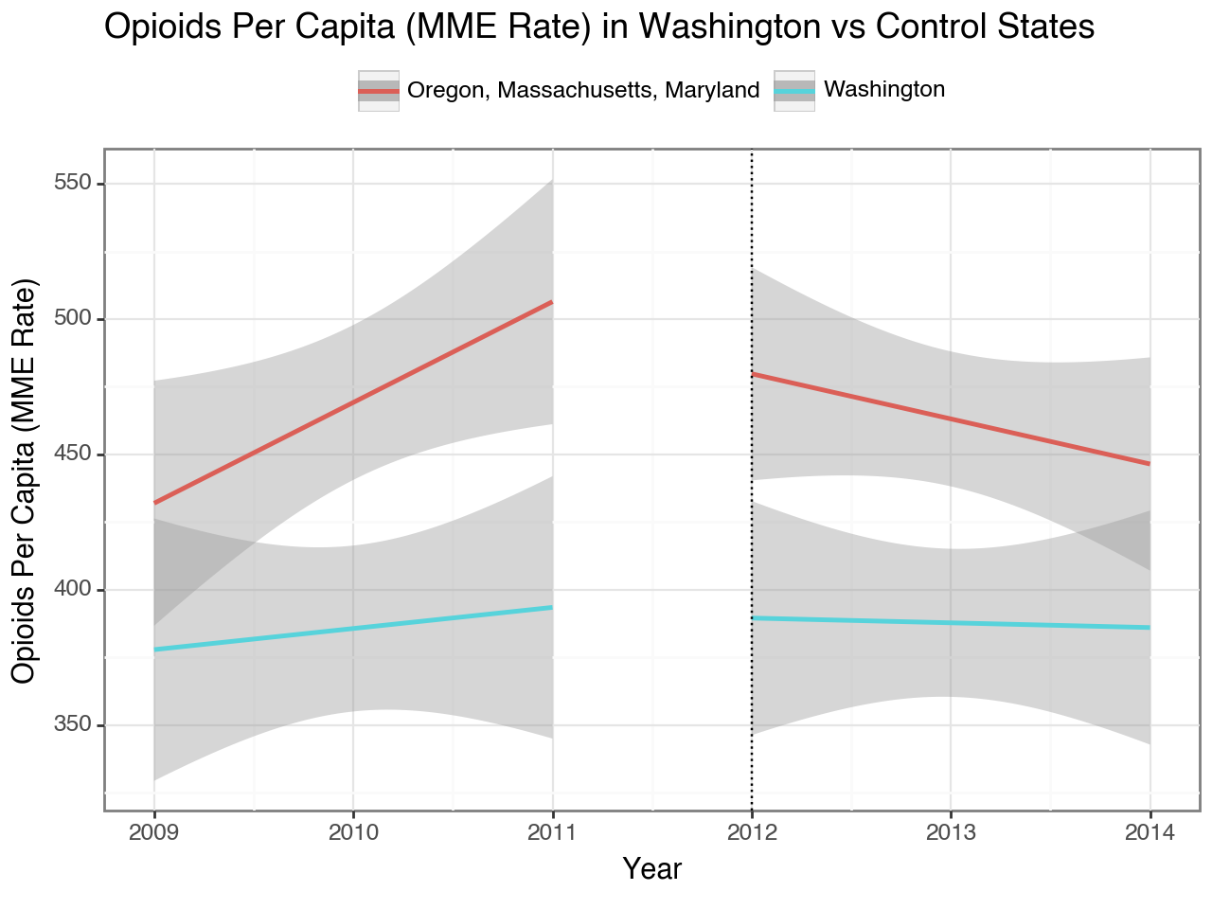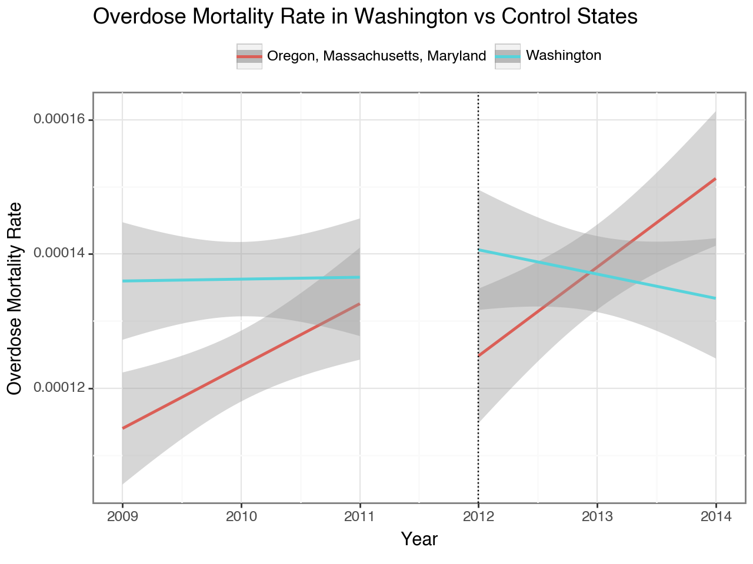

***Fig 8 and 9: The Diff-in-Diff Analysis for Washington for Opioids per capita (Fig 8: Left) and Mortality Rate (Fig 9: Right)***

Before the policy intervention, Washington's overdose mortality rates exhibited a modest upward trend, while the control states experienced a more pronounced increase. Although the trends for both groups were not perfectly parallel, they were sufficiently similar to facilitate comparison. Following the intervention, Washington's overdose mortality rate showed a notable decline, in contrast to the control states, where the rates continued to ascend. This divergence suggests that the policy enacted in Washington around 2012 might have played a role in mitigating overdose mortality rates there.

Concurrently, analysis of the opioids per capita indicates a modest rise for Washington and a steep rise for the control states before the policy was introduced. The trends in this case were largely parallel, indicating comparability. Post-intervention, there was a sharp reduction in the opioids per capita for the control states and a modest reduction for Washington. Given that both demonstrated decreasing trends, it's challenging to attribute Washington's decline solely to the state's policy intervention. It's plausible that other factors, such as nationwide opioid control initiatives or separate policies within the control states, contributed to the downward trends observed in both.

Therefore, when synthesizing the outcomes from Washington's Difference-in-Differences analyses presented in the two graphs, it is inconclusive that the 2012 policy was efficacious in diminishing the opioids per capita. It appears that the intervention in Washington did not yield a reduction in opioid dispensation that was distinct from the trends observed in the control states.

### Texas

Building upon the pre-post analysis, we included three control states, Alabama, South Carolina, and Tennessee for Texas's DiD analysis. The graphs below show the overdose mortality rate in Texas versus control states (Alabama, South Carolina, Tennessee) over the years 2004 to 2009. The opioid intervention policies in Texas were in effect in 2007, thereby our reference year for Texas’s DiD analysis is **2007**.

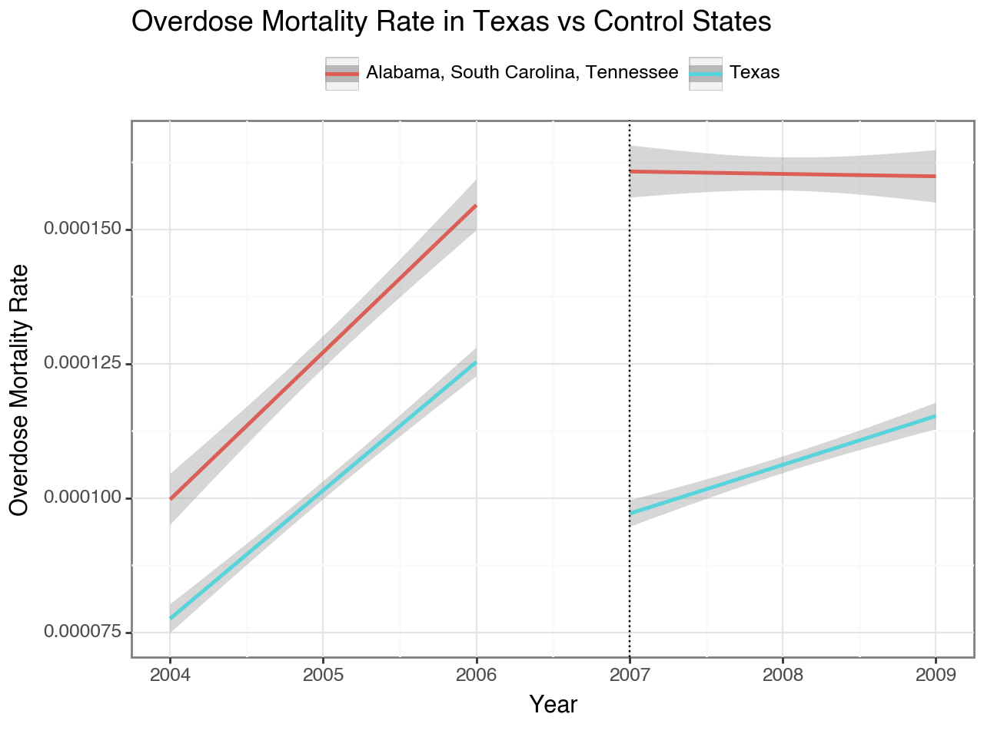

***Fig 10: The Diff-in-Diff Analysis for Texas for Mortality Rate***

Prior to the policy intervention, both Texas and the control states demonstrated a rising trend in overdose mortality rates, indicating comparable conditions for both groups. Post-intervention, Texas's overdose mortality rate initially showed a significant decline, then continued to rise at a diminished rate compared to the pre-intervention period. Conversely, the control states experienced a modest decline in their overdose mortality rates following the intervention. The sharp initial decline in Texas, followed by a slower rise, juxtaposed with the slight decrease observed in the control states, complicates the task of attributing the changes in Texas solely to its policy intervention. It is possible that other elements, such as overarching national opioid control initiatives or other specific policies enacted in the control states, may have influenced the decelerating trend in Texas and the slight downward trend in the control states.

### Overall Comments on Diff-in-Diff Analysis

The DiD analysis adds valuable insights to the pre-post analysis by comparing the changes in outcomes between treatment and control groups. It acknowledges the potential influence of external factors and provides a more robust evaluation of the causal impact of drug usage control policies. The DiD analysis for Florida reinforces the positive impact of the drug usage control policy implemented in 2010. The divergence in both opioids per capita and mortality rate between Florida and the control states after the policy intervention suggests a significant and sustained reduction in opioid-related issues. The DiD analysis for Washington suggests a decline in overdose mortality rates post-policy intervention, indicating a positive impact. However, the results for opioids per capita are less conclusive, emphasizing the need for careful consideration of influencing factors. The analysis for Texas initially shows a positive impact on overdose mortality rates. However, subsequent trends and a modest decline in control states add complexity to attributing changes solely to Texas's policy intervention. In essence, when looking at a difference-in-difference analysis, we find out that the impact evaluation of policies are rather complex and it’s not apparent when looking at just statistical measures.

# Strengths and Limitations

## Strengths:

In our analysis, we are focusing on the pre-post analysis to evaluate the effect of the policy and then also looking at the difference in difference analysis to isolate the impact of the policy again, which helps us identify the ineffectiveness of the policy implemented by Washington. The difference in difference analysis helps us identify similar control states based on macroeconomic data and a similar trend with each of our treatment states. The analysis also focuses on a longitudinal approach, by looking at least 3 years pre and after the policy in order to arrive at a definitive conclusion. In the appendix, we also have two other versions of our selected control states, to see if there is any change in our conclusion of the effectiveness of the policy, eliminating our bias of selecting control states.

## Limitations:

There are a few limitations in our analysis pertaining to missing data in the data sources as well as a few assumptions we made about the data and during our analyses as well as while choosing control states for the difference in difference analysis.

Firstly, the Vital Statistics dataset provides information on deaths in the United States but to prevent the invasion of privacy for small counties where if any category of death for any year falls below 10 for a particular county, it doesn’t include that in the dataset. For this reason, we had to impute some missing data in a few counties based on the average death rate (Opioids related deaths per population) for the counties in that state. While this is a good proxy, this is in a sense “made up data”, which means the analysis is not free of limitations. Similarly, for population, since the official census in the US happens every ten years, data imputation for population was also required, which makes our population, and hence the MME rate and mortality rate an estimation rather than a deterministic value.

Another limitation is that the policies in Texas, Washington and Florida were policies that undertook a proper planning and implementation phase and it’s not a fair analysis to analyze these policies by attributing them to a single year. Also, some policies can take a few years to show their impact, so it’s not accurate to deem a policy ineffective if the policy didn’t show plausible results in the years right after it was implemented.

While selecting control states, we looked at several macroeconomic factors such as poverty, GDP per capita etc. as well as look at the Opioid related trends if they’re comparable to our treatment states. Then we take a holistic approach to select the final 3 control states for each of our three treatment states. While this approach makes sense statistically and logically, it is also important to know that we can not fully isolate the effects of policy changes for our treatment states because Opioid consumption and drug related problems have been a long-standing problem in the US and many states have some form of control of drug usage and hence the trends are affected by those policy changes as well. Policies such as implementing prescription drug monitoring programs (PDMPs) and regulation of pain management clinics are common within the US on a national and state level. Thus, isolating and looking at the causal effect of the policy is complex in this case.

Lastly, there is a difference between the formulation and the implementation of a policy. A policy can be good in theory but can be ineffective if not implemented properly. We don’t have sufficient data to monitor effects of the policy being implemented hence that is something out of the scope of our analyses. We assume that the policy changes were fully implemented and thus are assessing the aforementioned policies based on that.

# Conclusion

Based on our analysis, if we just look at the pre-post analysis, it can be concluded that the policies did impact opioid usage as they decreased the mortality rate and shipment rate trends for all 3 states after the policy came into play. However, after looking at the difference-in-difference analysis, it was found that Washington’s policy in 2012 was not entirely effective based on the post-policy change we saw in the trend for the control states we selected for Washington (Oregon, Massachusetts, Maryland). For Texas, we only evaluated the mortality rate, and according to our analysis, the policy implemented in 2007 was not entirely effective with the decelerating trend in Texas and a slight downward trend in the control states (Alabama, South Carolina, Tennessee) after the policy intervention. This might be because of the unsuccessful nature of the policy itself or because of other factors that also contribute to drug usage which our analysis failed to identify. It was seen that Florida’s policy was the most successful as it reversed the increasing trend entirely, even when the control states (Ohio, Oklahoma, Arkansas) saw an increasing or stable trend. This might be due to a more stringent implementation in the policy for Florida beginning in 2010 like a **state-wide raid,** the **Operation Pill Nation and the arrests and closures of several pain clinics** as well as the creation of the **Statewide Task force.** Due to the urgent nature of the problem in Florida, the DEA had laid out several mechanisms for a strict implementation of the policy. It can serve as a case-study for Washington, Texas, and other states in the US planning to reduce the problems of Opioid consumption.

# Appendices

**Control State selection iteration # 1:**

The curation of control states based on the specified criteria above was an essential preparatory step, the subsequent decision to exclude these figures from the final analysis underscores our commitment to methodological rigor and the adherence to a focused research framework.

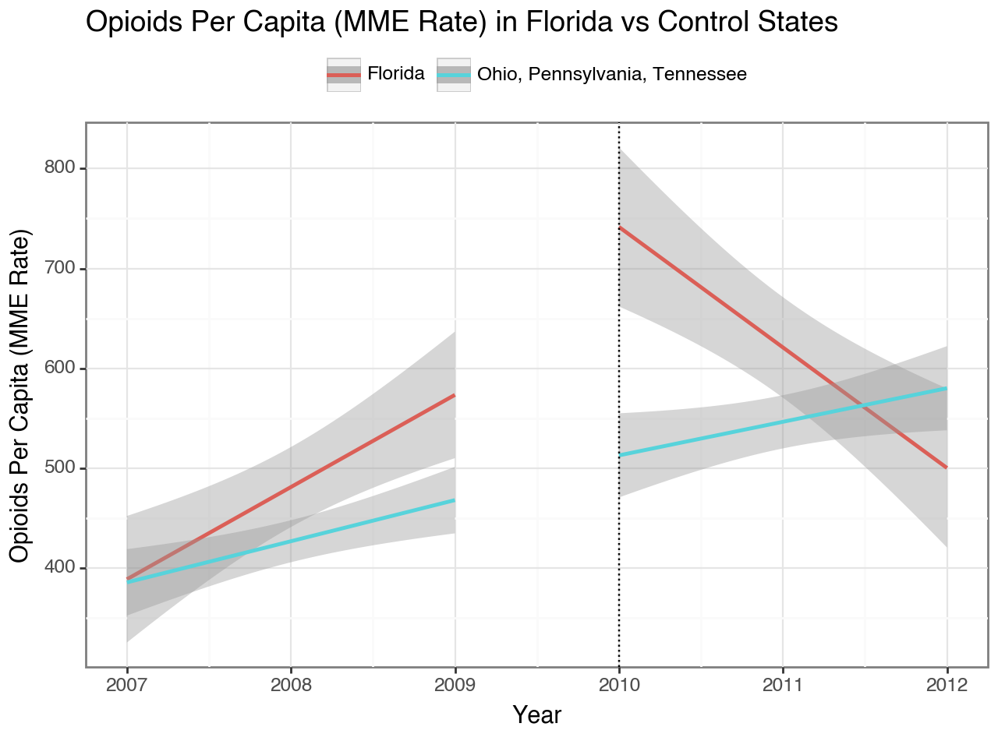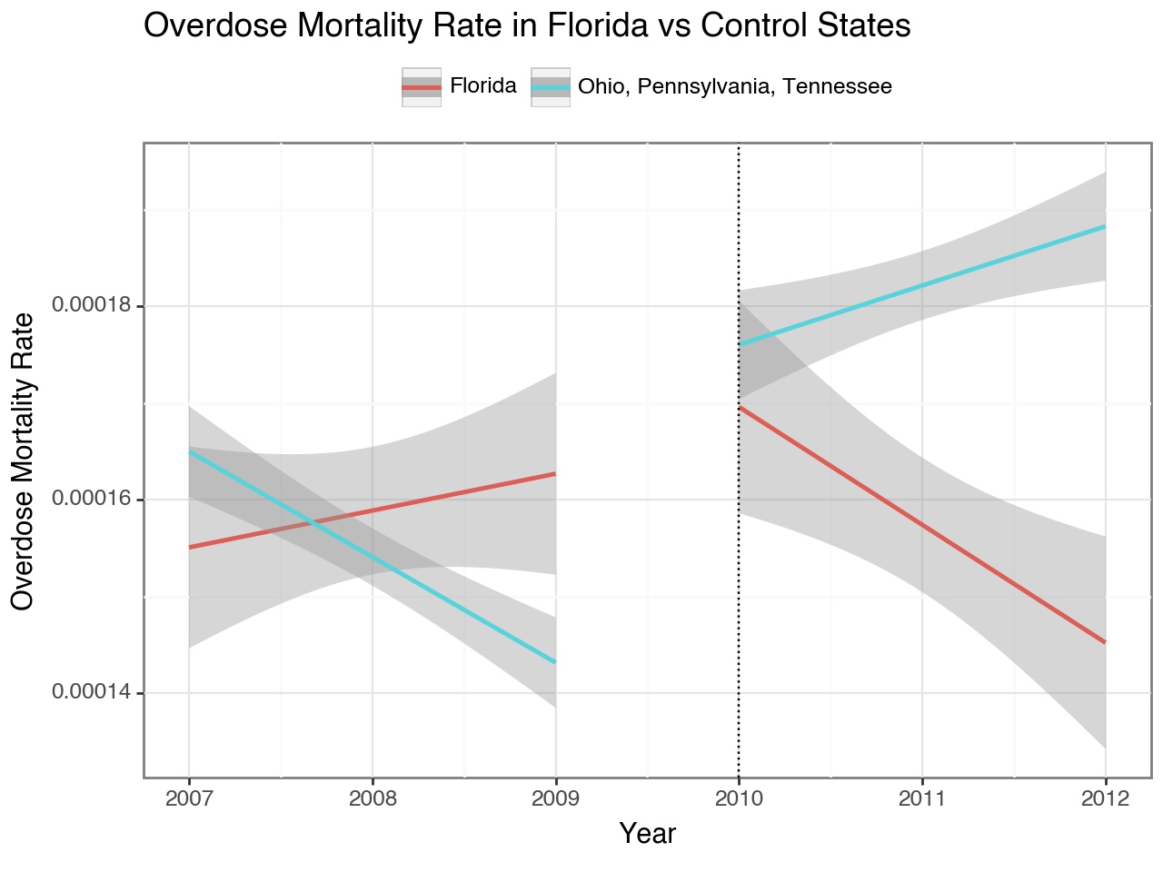

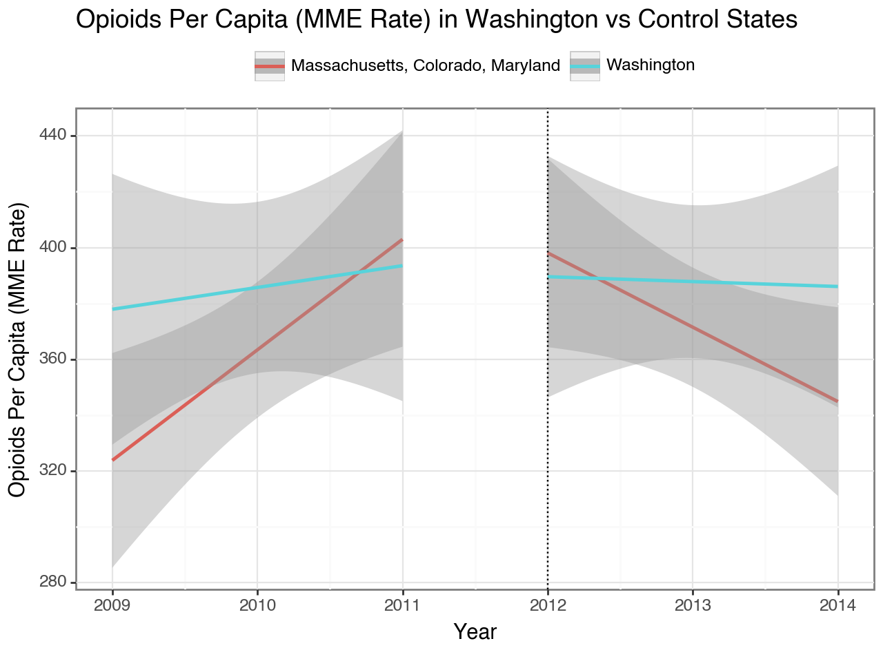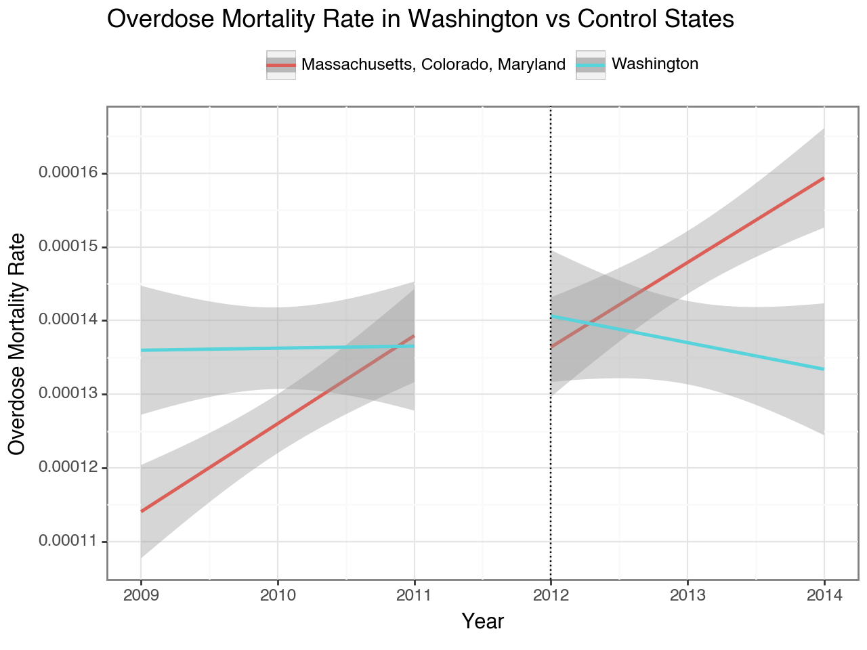

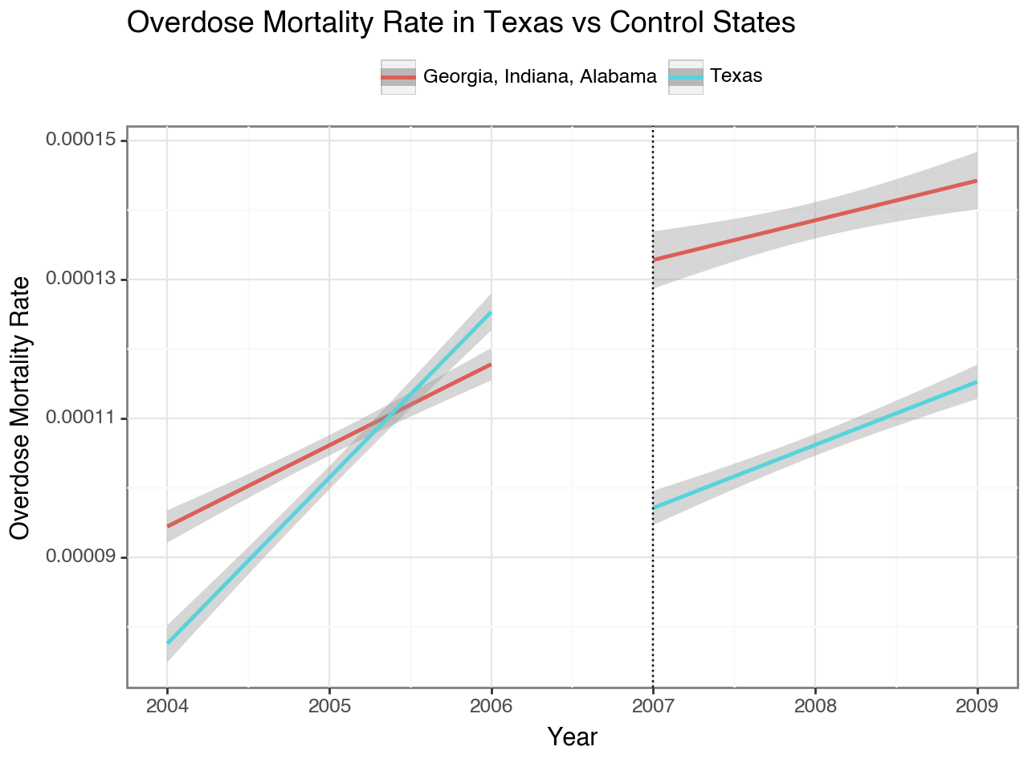

**Control State Iteration #2:**

In the appendix, the chosen control states were strategically identified based on geographic considerations, with a primary focus on states that could readily facilitate the transportation of high-dose shipments. Additionally, the selection process considered data from the Centers for Disease Control and Prevention (CDC), which highlighted states experiencing the highest rates of drug-related fatalities. This dual criterion—geographical feasibility and elevated drug-related death rates—guided the selection of control states for the study.

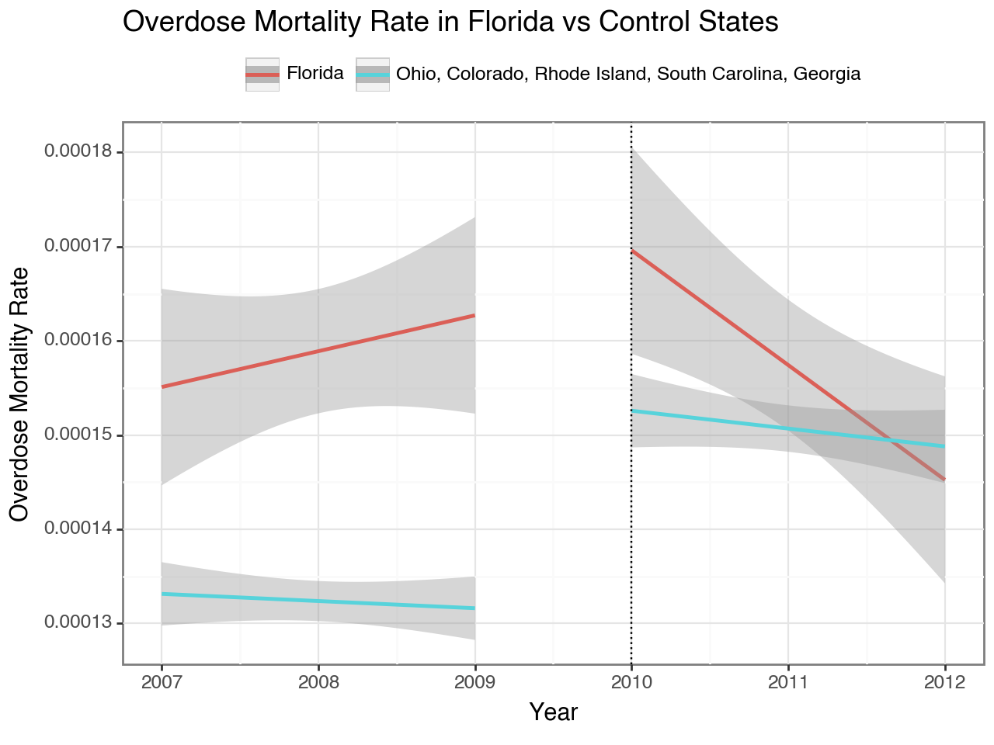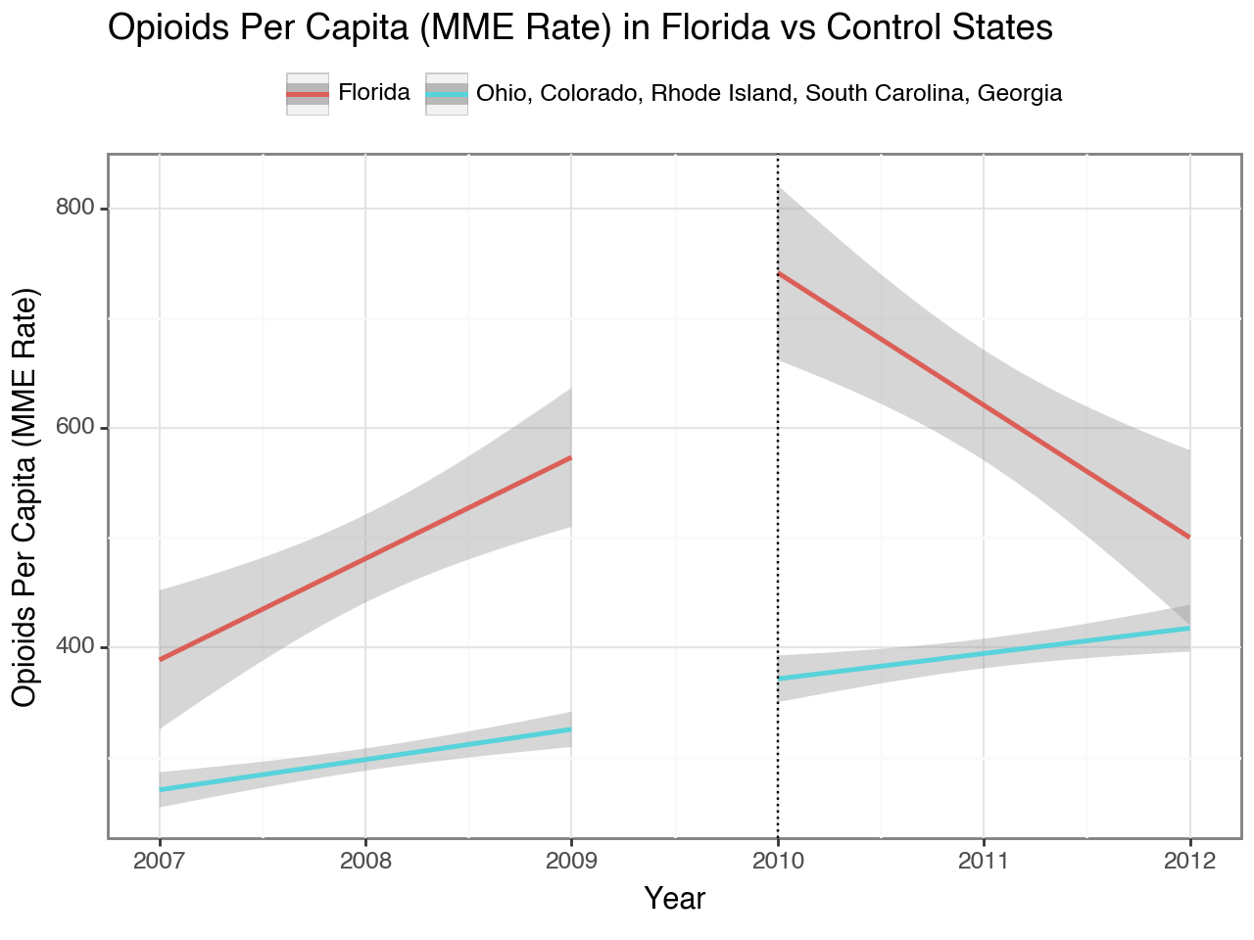

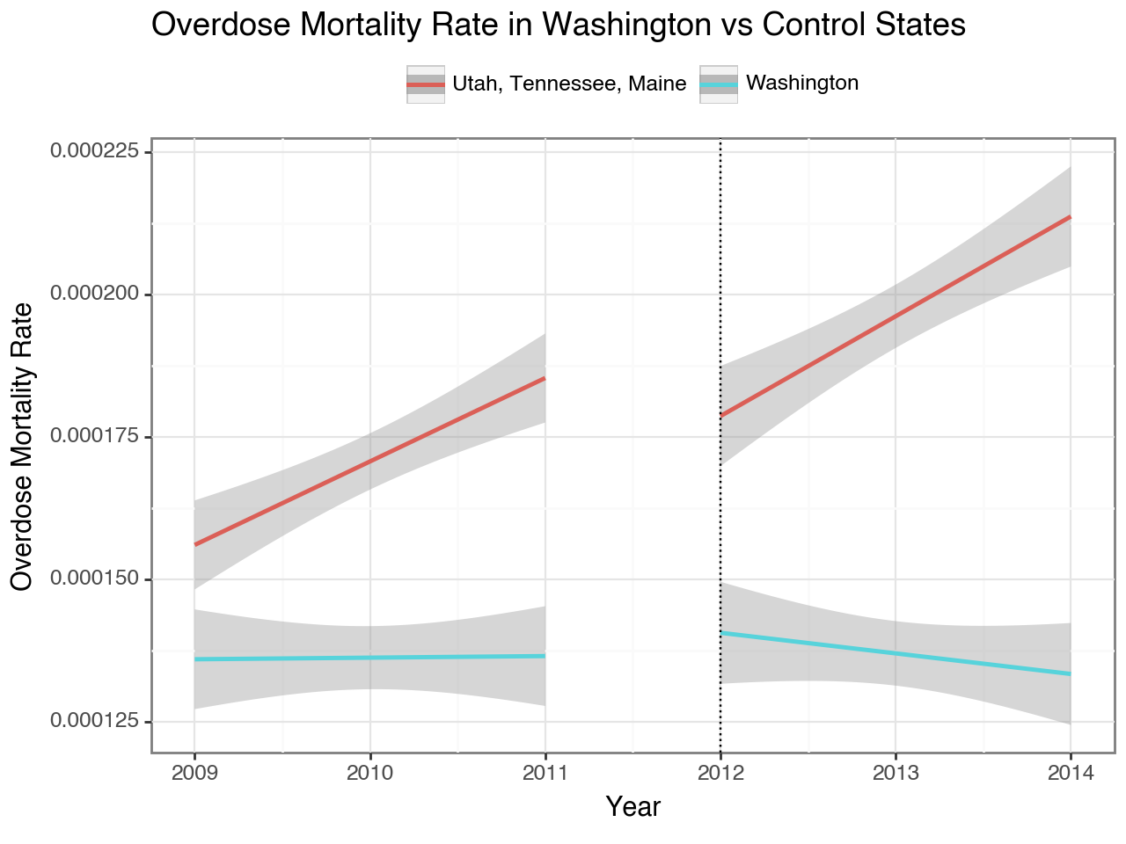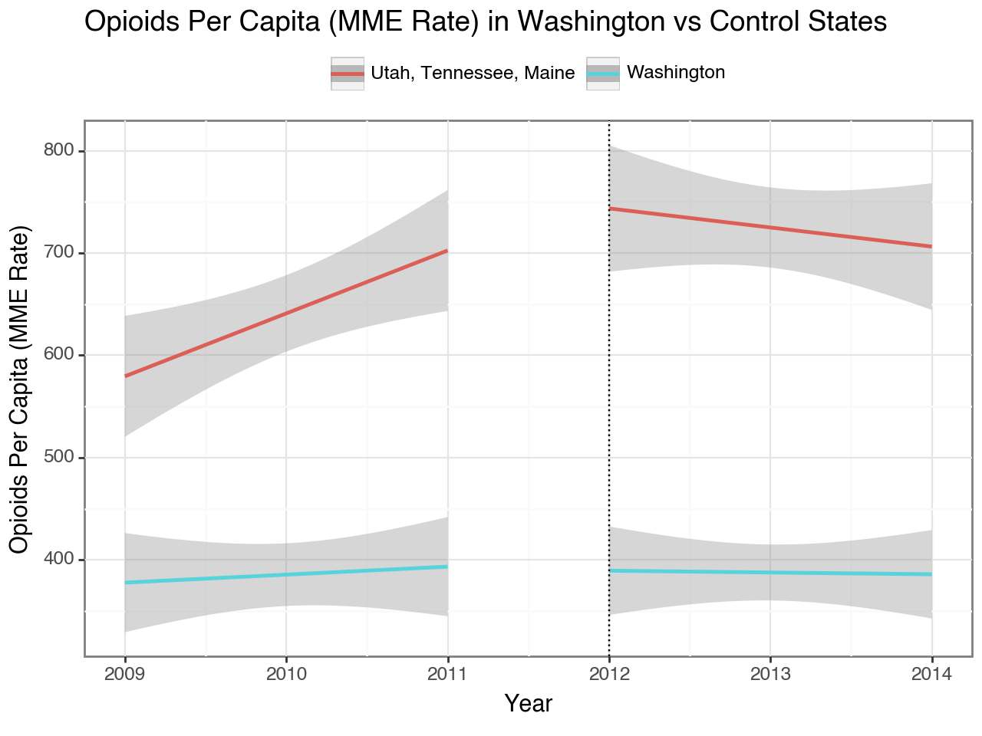

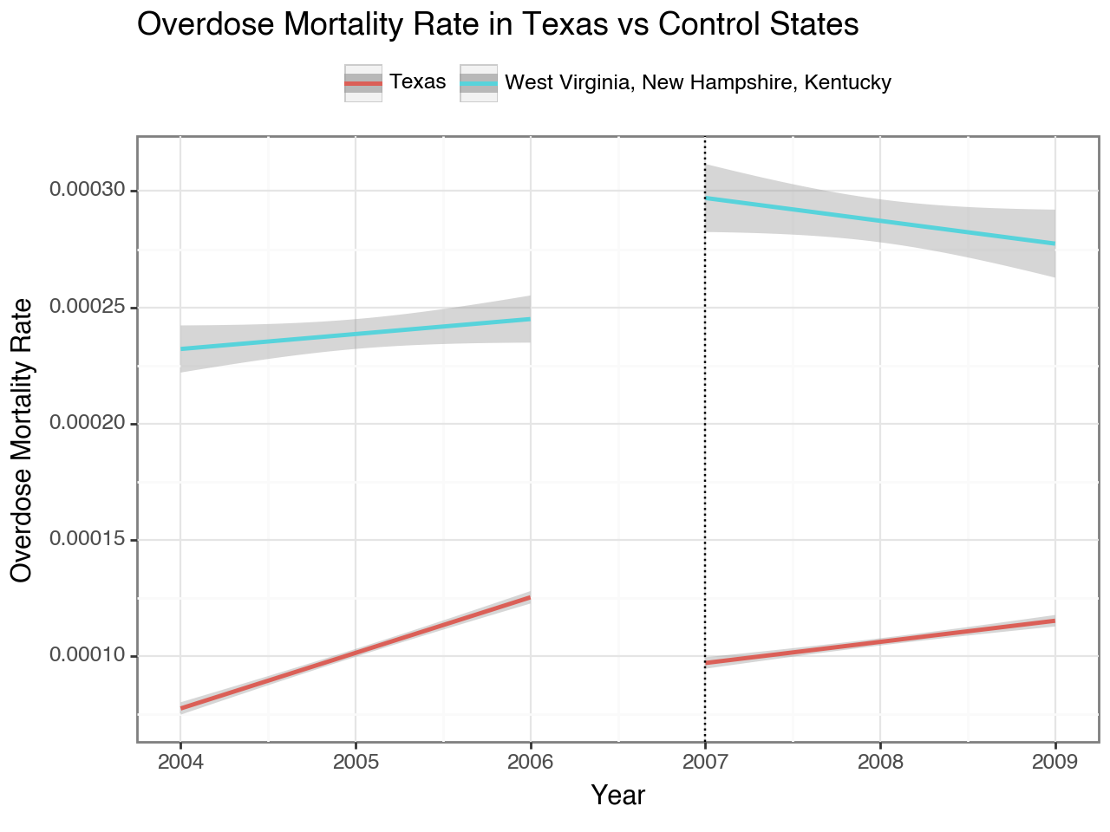

**Control States Iteration #3:**

In the appendix, we employed a multifaceted approach to refine the selection of control states. Beyond the factors previously outlined, a visual confirmation process was integral, wherein we identified control states exhibiting the most parallel trend lines to our specific states of interest. This visual alignment aided in the streamlined selection process.

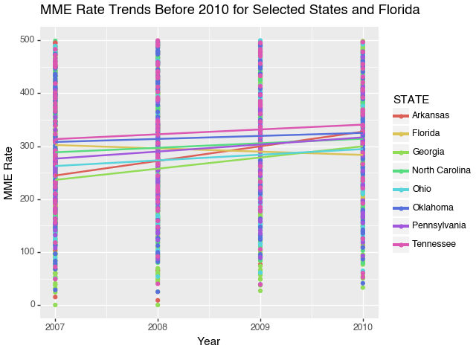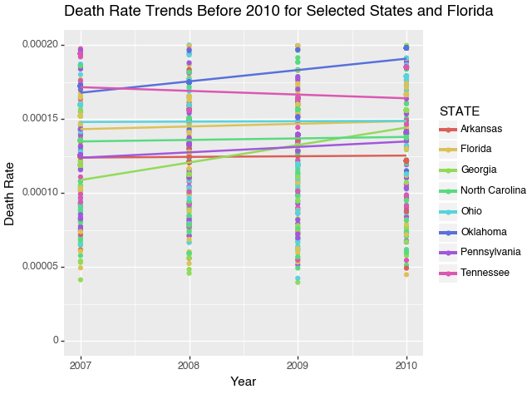

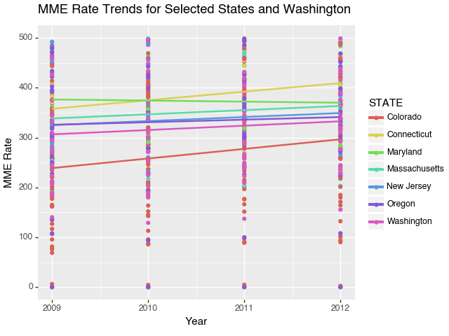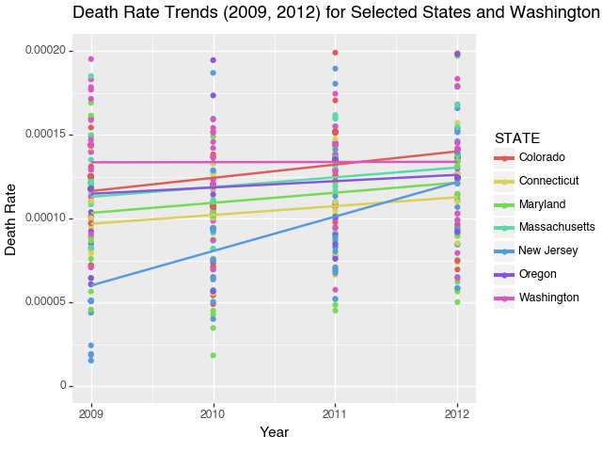

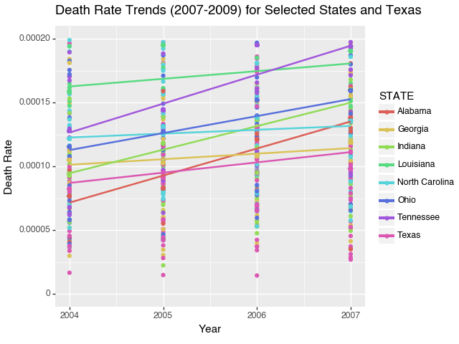

# References

Bureau of Labor Statistics. (2010, March 3). The employment situation - February 2010 [Press release].<https://www.bls.gov/news.release/archives/srgune_03032010.pdf>

Bureau of Labor Statistics. (2012, February 29). The employment situation - January 2012 [Press release].<https://www.bls.gov/news.release/archives/srgune_02292012.pdf>

Bureau of Labor Statistics. (2007, March 2). The employment situation: February 2007 [Press release].<https://www.bls.gov/news.release/archives/srgune_03022007.pdf>

Crissey, S. R. (2009). Educational attainment in the United States: 2007. U.S. Census Bureau.<https://www2.census.gov/library/publications/2009/acs/acs-09.pdf>

Delgado, M. K., Shofer, F. S., Patel, M. S., Halpern, S., Edwards, C., Meisel, Z. F., & Perrone, J. (2017). Association between electronic medical record implementation of default opioid prescription quantities and prescribing behavior in two emergency departments. Journal of general internal medicine, 32(4), 406–411.<https://doi.org/10.1007/s11606-016-3921-9>

Ghertner, R., & Groves, L. (2018). The opioid crisis and economic opportunity: geographic and economic trends. NCBI.<https://www.ncbi.nlm.nih.gov/pmc/articles/PMC6348390/>

Howden, L. M., & Meyer, J. A. (2011). Age and sex composition: 2010. U.S. Census Bureau.<https://www2.census.gov/library/publications/2011/acs/acsbr10-01.pdf>

Jamison, R. N., Scanlan, E., Matthews, M. L., Jurcik, D. C., & Ross, E. L. (2016). Attitudes of primary care practitioners in managing chronic pain patients prescribed opioids for pain: A prospective longitudinal controlled trial. BMC family practice, 17(1), 1-9.<https://www.ncbi.nlm.nih.gov/pmc/articles/PMC5565130/>

Kaiser Family Foundation. (2021). Health spending per capita by state of residence.<https://www.kff.org/other/state-indicator/health-spending-per-capita/?currentTimeframe=14&amp;selectedRows=%7B%22states%22:%7B%22texas%22:%7B%7D,%22alabama%22:%7B%7D,%22south-carolina%22:%7B%7D,%22tennessee%22:%7B%7D%7D%7D&amp;sortModel=%7B%22colId%22:%22Location%22,%22sort%22:%22asc%22%7D>

Limiting Initial Opioid Prescribing: State-By-State Overview. (2019). Pharmacy Times.<https://www.pharmacytimes.com/view/opioid-prescribing-limits-across-the-states>